NEL4 Module 5:
Network Systems Administration

Live event: Learner Activity Document


Contents
Activity 1: Choosing Tower or Rack Mount Server 1
Activity 2: Recommend HDD vs SSD 3
Activity 3: Recommend DAS-NAS-SAN storage 5
Activity 4: Recommend RAID storage solution 7
Activity 5: Create and verify RAID setup 9
Activity 6: RAID multiple choice quiz 12
Activity 7: Recommend Windows vs Linux Server 16
Activity 8: Windows and Linux server install 18
Activity 9: Install Active Directory Domain Services 23
Activity 10: SNMP Configuration 25
Activity 11: System upgrading and testing 30
Activity 12: System performance improvement 33
Activity 13: System performance monitoring 36
Activity 14: Service Level Agreement 40
Activity 15: Policy and procedure 43
Activity 16: Server backup 46
Activity 17: Client remote backup 48
Activity 18: Disaster recovery planning (DRP) 50
Activity 19: Change management compliance 53
Lab virtual machines credentials 56

Activity 1: Choosing Tower or Rack Mount Server

Scenario
You are the network engineer for a growing small business that provides digital marketing services. Your business has 30 employees and plans to expand to 60 employees in the next couple of years. The business currently uses cloud-based file storage, but with increasing data security concerns and a need for better internal collaboration, the company is considering purchasing a dedicated server.
After evaluating different server types, you are presented with two options:
- Tower server.
- Rack mount server.

Objectives
- Analyse the business case and recommend the right server type.
- Demonstrate some understanding of the differences between a tower and rack server type.

Step 1: Ask questions for your recommendation
Compose 1-2 questions each on the following factors that you would ask the business before making your recommendations.
- Business needs
- Cost
- Scalability and growth
- Technical requirements

Step 2: Make a recommendation
Based on your questions and assumptions, decide if your business should deploy a tower or rack mount server.
After making your decision, provide some justifications for your decision using the following reflective questions:
- List some factors that influenced your decision making.
- If your business grows beyond 60 employees, how will your decision impact the business?
- What potential risks can you think of when choosing a tower server over a rack server?
- What additional information would help you make a more informed decision?

Activity 2: Recommend HDD vs SSD

Scenario
You are the network engineer for an MSP (LB Solutions) that handles large data storage and processing for small to medium enterprise. Your business is upgrading their storage infrastructure, and you have been delegated to make decision on whether to implement HDDs (Hard Disk Drives) or SSDs (Solid State Drives).
There is a cost constraint as the implementation budget is limited. However, your business has made recommendations around a solution that can provide high reliability, speed, cost-effectiveness, and capacity.
You need to assess the best storage solution based on the business requirements with two options below:
- HDD
- SSD

Objectives
- Analyse the business case and recommend the right storage solution.

Step 1: Understand business requirements
The business department’s specific storage needs:
Department | Storage requirement | Performance need
Finance | Secure storage for financial records and transactions | Medium
HR | Employee records | Low
Data science | Large-scale data processing and analytics tasks | High
IT | Log files, system backups, and security data | Medium
Graphic developers | Graphic/video files requiring fast access | High
The project constraints are:
- Budget: Limited.
- Storage reliability: Must be high.
- Performance needs: Some departments require high performance access.
- Future scalability: Some departments will require scope to scale due to the business growth.
- Storage size: Graphic developers will require large scale capacity.

Step 2: Carry out research to compare HDD and SSD
Feature | Hard Disk Drive (HDD) | Solid State Drive (SSD)
Speed
Durability
Cost
Capacity
Lifespan
Question: Considering the requirements for each department and internet research, which solution (HDD, SSD, or Hybrid) would you recommend and why?

Step 3: Decision justification
Answer the following questions now that you’ve made your recommendations:
- How will your choice support future business growth?

- What risks are associated with your choice, and how can you mitigate them?

Reflection
- What were the most important factors in your decision?

- How does the performance of SSDs and HDDs affect overall business productivity?

- If a department requires both high speed, cost efficiency and large storage capacity, how would you implement a hybrid solution?

- How would your decision change for a small business compared to a large enterprise?

Activity 3: Recommend DAS-NAS-SAN storage

Scenario
You are an IT Network Consultant subcontracted by LB Solutions, a business with 200 employees across multiple departments. The company has recently faced some data storage challenges and are currently looking for a solution to implement a scalable, efficient, and cost-effective storage deployment solution.

Objectives
Analyse the business case and recommend any of the following storage solutions.
- DAS (Direct-Attached Storage)
- NAS (Network-Attached Storage)
- SAN (Storage Area Network)

Step 1: Analyse the business storage requirements
Department | Storage needs | Performance required | Scalability | Data sharing required
Finance | Secure and fast access to financial records | High | Medium | No
Design and creative team | Large video and image files, quick retrieval | High | High | Yes
IT team | Backup, cybersecurity logs, system images | Medium | High | Yes
HR | Employee records and reports | Low | Medium | Yes
Data analytics | Large-scale data processing and real-time access | Very high | Very high | Yes

The project constraints are:
- Budget: Moderate.
- Reliability: Must support critical business functions.
- Scalability: Should accommodate future growth.
- Collaboration needs: Some teams require shared access to date.

Step 2: Evaluating storage options
Carry out internet research and do a comparison between each of the storage implementation types. Then, make your recommendations based on the business requirements and constraints.
Question: Based on the company’s requirements and your research outcome, which storage solution (DAS, NAS, or SAN) would you recommend and why?

Step 3: Implementation
Answer the following questions now that you've selected your preferred solution:
- How will your solution support future growth and scalability within each department?

- What impact will your solution have on data security and access management?

- What would be the impact of your solution if the business decides to expand to multiple locations. Will your solution still be effective?

Reflection
- Which factors were the most important in your decision making?

- What would you recommend if this was a business with over 1000 users? Why?

- What are the trade-offs between each of the storage implementation types in relation to performance, cost, and scalability?

Activity 4: Recommend RAID storage solution

Scenario
You are a network engineer at LB Solutions, a business that deals with large volumes of critical data. Recently, the business has experienced data loss and significant performance issues in its storage systems, leading to a couple of hours downtime and operational inefficiencies. The management team has delegated you to implement a RAID (Redundant Array of Independent Disks) storage solution to improve data protection, performance, and redundancy.

Objectives
Analyse the business case and recommend the best RAID level for their storage needs.

Step 1: Understanding business requirements
The business department’s specific storage needs:
Department | Storage requirement | Key priority | Performance need | Fault tolerance needed?
Finance | Secure storage for financial records and transactions | High reliability | Medium | Yes
HR | Employee records | High redundancy | Low | Yes
Data science | Large-scale data processing and analytics tasks | Performance | High | Moderate
IT | Log files, system backups, and security data | High redundancy | Medium | Yes
Graphic developers | Graphic/video files requiring fast access | Performance | High | Moderate
The project constraints are:
- Budget: Moderate.
- Storage efficiency: Needs to maximise storage usability.
- Performance vs. redundancy trade-offs: Must balance performance and high availability.
- Business continuity: Critical departments cannot afford data loss or downtime.

Step 2: Analyse and compare between RAID deployment options
Carry out internet research and do a comparison between each of the storage RAID implementation options. Then, make your recommendations based on the business requirements and constraints.
RAID level | Description | Performance | Fault tolerance | Storage efficiency | Typical use case
RAID 0
RAID 1
RAID 5
RAID 6
RAID 10 (1+0)
Question: Considering the requirements for each department and your internet research, which solution RAID options would you recommend and why?

Step 3: Decision justification
Answer the following questions now that you’ve made your recommendations on the RAID type to implement:
- How does your recommendation balance performance and fault tolerance?

- Will your solution remain effective if the business data storage requirement grows?

- What risks are associated with your chosen RAID level, and how can they be mitigated?

Reflection
- What influenced your RAID deployment option the most (performance/reliability)?

- In what ways does RAID improve business continuity and disaster recovery?

Activity 5: Create and verify RAID setup
This task looks at configuring RAID on Windows Server OS. You will have to configure a variety of settings to enable this to be done.

Objectives
After completing this lab, you will be able to:
- Configure software RAID on Windows Server.
- Explain the difference between Basic and Dynamic Disks in Windows.
Estimated total lab time: 20 minutes

Step 1: Add disks to VM
In this first task, you will be adding multiple disk drives to the existing virtual machine to configure RAID on.
- Double click the Hyper-V Manager on a desktop to open it.
- In Hyper-V Manager, create three additional virtual Hard Disks, using the instructions below.
- On the Hyper-V manager, select new and then select Hard Disk.
- Select next, select VHD and next.
- Select Dynamically expanding and select next.
- Enter Disk 1 in the name field and select next.
- Select finish to complete the process.
- Repeat steps 3 to 6 and add two additional disks by changing the disk number. For example, Disk 2, Disk 3.

Step 2: Attach the Disk 1, 2, 3 to DC
- Right click DC and select settings.
- Make sure Add Hardware is highlighted and SCSI Controller is selected.
- Select add.
- In the SCSI Control menu, Select Add.
- Select browse, select Disk 1, and click open.
- Select apply and then OK.
- Repeat steps 1 - 7 to attach Disk 2 and Disk 3.
Step 3: Setup RAID storage
- Right click DC, select connect, and start.
- Select the three icons on the top left to bring up the logon screen.
- Log in using the credentials below:
  - Username: QAA\Administrator
  - Password: Pa$$w0rd
- Minimise the Server Manager window.
- Right click start and select Disk Management.
Note: Disks 1, 2, 3 should be listed in the disk manager as offline and unknown.
Note: You should get initialisation pop-up. If not then proceed to initialise the disks using the steps below.
- Right click Disk 1 and select Online. If the disk is already online then move on to do the same for Disk 2 and Disk 3.
- Right click Disk 1 and select Initialise Disk.
- Make sure Disks 1, 2, 3 are selected and then select the GPT partition and click OK.
Note: Basic disks are the standard storage type used in Windows. They use partitions which are usually formatted with a file system. Dynamic disks on the other hand, provide some additional features, including the ability to create striped and fault tolerant volumes. You can convert a basic disk to Dynamic Disk without any data loss. You cannot revert it without formatting the drive.
Read more about the disk types.
- Right click Disk 1 and select Convert to Dynamic Disk to convert to a dynamic disk.
- Select Disks 1, 2 and 3 to convert all three disk drives and select OK.
- Select Convert to begin the process.
- Once the drives have converted, you will create a RAID 5 volume across the three new disks.
- Right click on Disk1 and select New RAID 5 volume.
- Select next when the New RAID-5 Volume wizard will open.
- Add Disks 2 and 3 to the selected disks and select Next.
- Assign drive letter G and select Next.
- Format the disks with the default NTFS settings, select Next and then Finish to complete the setup.
Note: The disks will then be formatted as a RAID-5 volume. This may take around 20 minutes to complete.

Step 4: Test RAID fault tolerance
The next steps is a short demo of how resilient RAID storage is when there is one or more disks failure.
- Open folder explorer where you can see the new G drive, consisting of the three disks configured as RAID.
- Create and save a file or folder inside the G drive.
- Open Disk Manager console, if not already open.
- Right click Disk 2 and select Offline to simulate disk failure.
- Go back to the G drive.
- Your folder/file will still be present irrespective of one of the disk failure.
End of the lab.

Activity 6: RAID multiple choice quiz
This activity is a quick quiz regarding the differences between the RAID levels and what their limitations are.
- Which RAID level provides performance enhancements but no-fault tolerance?
  - RAID 0
  - RAID 1
  - RAID 5
  - RAID 6

- Which RAID level uses mirroring to provide fault tolerance?
  - RAID 0
  - RAID 1
  - RAID 5
  - RAID 6

- Which RAID level uses nesting to provide both performance enhancements through striping and fault tolerance through mirroring?
  - RAID 05
  - RAID 10
  - RAID 50
  - RAID 60

- Which RAID level uses standard (single) striped parity to provide redundancy?
  - RAID 0
  - RAID 1
  - RAID 5
  - RAID 6

- Which RAID level is also known as double parity RAID?
  - RAID 0
  - RAID 1
  - RAID 5
  - RAID 6

- Which RAID term describes the result of an XOR calculation performed on each disk in a set?
  - Hot spare
  - Parity
  - Redundancy level
  - Array split

- Which RAID level is the fastest?
  - RAID 0
  - RAID 1
  - RAID 5
  - RAID 6

- Which RAID level can only use 50% of the total disk space?
  - RAID 0
  - RAID 1
  - RAID 5
  - RAID 6

- Which RAID level requires three or more disks?
  - RAID 0
  - RAID 1
  - RAID 5
  - RAID 6

- Which RAID level can tolerate two disk failures?
  - RAID 0
  - RAID 1
  - RAID 5
  - RAID 6

- Given three disk drives of 2TB each, which level of RAID would provide the best usage of storage space, whilst also providing basic fault tolerance?
  - RAID 0
  - RAID 1
  - RAID 5
  - RAID 6

- Which RAID level should you recommend for a system requiring the best transfer rates which can tolerate total data loss?
  - RAID 0
  - RAID 1
  - RAID 5
  - RAID 6

- Which RAID level provides a total volume capacity equal to all disks?
  - RAID 0
  - RAID 1
  - RAID 5
  - RAID 6
- You are inspecting a RAID system and note that it has seven disks each containing 500GB of space. You find that the total available disk space is 3TB. Which RAID level is in use?
  - RAID 0
  - RAID 1
  - RAID 5
  - RAID 6

- Which one of these is characteristic of RAID 5?
  - Distributed parity
  - No parity
  - All parity in a single disk
  - Double parity

- Which of the following raid levels provides maximum usable disk space?
  - RAID 1
  - RAID 0
  - RAID 5
  - RAID 6

- You are working with a media house using a lot of graphics/video applications. They need large throughput for video playback without any jitter and since they are a publishing business, they cannot afford downtime. Even if there is any downtime the data needs to be quickly reconstructed to enable work to continue as quickly as possible. Which RAID level should you recommend?
  - RAID 5
  - RAID 10
  - RAID 6
  - RAID 01

- You are setting up a new RAID system with seven drives. You require improved read performance and fault tolerance for two disk failures. You also need to ensure you make the most of the space available across the disks. Which RAID level should you choose?
  - RAID 0
  - RAID 15
  - RAID 5
  - RAID 6

Activity 7: Recommend Windows vs Linux Server

Scenario
You are part of the network Team at LB Solutions, a fast-growing company that needs to setup a new server infrastructure in one of their corporate headquarters to support its expanding operations. Your business is considering Windows Server or Linux Server, and you have been delegated the task of evaluating both options and recommend the best solution to meet the business needs.

Objectives
Recommend a server solution for a new corporate headquarters.

Step 1: Understanding business requirements
The new branch will have multiple departments with the following requirements server requirements:
Department | Server Usage | Key consideration | Ease of management required | Security requirements
Finance | Secure financial database transactions | Security and stability, ease of use | High | Very high
HR | Internal web portal and document storage | Ease of use | Very high | High
Sales | Document and marketing database | Ease of use | Very high | Moderate
IT | Apps deployment tools, system monitoring | Customisable, flexibility | Low | Very high
Graphic developers | Hosting large multimedia files | Performance and flexibility | Low | Moderate
The project constraints are:
- Budget: Moderate.
- Reliability: There should be less downtime with the critical business applications.
- Scalability: There is a plan to expand the server infrastructure in the future.
- IT team expertise: The IT team have very good knowledge of Windows but has limited Linux experience.

Step 2: Evaluating Windows and Linux Server Options
Carry out research and populate the table below that will help in you in presenting recommendations.
Feature | Windows Server | Linux Server
Security
Performance
Cost
Ease of use
Customisation
Question: Considering the business requirements and internet research, which of the server OS would you recommend and why?

Step 3: Decision justification
Answer the following questions now that you’ve made your recommendations:
- How does your solution align with the business current IT skill set?

- How will your decision impact the future server upgrades and scalability in the business?

- What are the potential security risks of your choice, and how can they be mitigated?

Reflection
- What critical factors did you consider when making your decision making?

- Would a hybrid approach be more beneficial for the business? Why (using both Windows and Linux)?

Activity 8: Windows and Linux server install

This activity involves installation and configuration of Windows Server 2019 and Linux Ubuntu Server. You will be using these virtual machines for many other labs, so please ensure you have them working or ask your trainer if you need help. Your trainer will have included a copy of the Windows Server 2019 iso file and the Linux Ubuntu Server iso file in the class share, so you must copy these across to your desktop before you begin.

Objectives
In this task, you will be installing Windows Server 2019 and performing the main post-installation configuration tasks. Follow the list below to identify what needs to be done. Ask your trainer if you need any help.
After completing this lab, you will be able to:
- Install Windows Server 2019.
- Install Linux Ubuntu Server.
- Undertake post-configuration activities on a server.
Estimated total lab time: 60 minutes.

Step 1: Windows Server Install
- Log into the host PC (GOTOMYPC / Learnondemand).
- Create a new Private Virtual Switch named Vnet_Apps for your server to connect to using the images below as a guide.
- Select Hyper-V Manager.
- Select Virtual Switch Manager.
- Select Private from the list to create an isolated network switch and select Create Virtual Switch.
- Enter Vnet_Apps as the name of the new network connection and select OK.
- Create a new virtual machine in Hyper-V Manager and name it with appropriate naming conventions so you can identify it again later (for example, Windows Server 2019).
Use the settings:
  - Select New > Virtual Machine > Next.
- On the Specify Name and Location tab, enter Windows 2019 and select Next.
- On the Specify Generation tab, leave the default Generation 1 selected and Select Next.
- On the Assign Memory tab, change the memory from 1024 to 2048 and then select Next.
- On the Configure Networking tab, select the Vnet_Apps from the drop-down menu and choose Next.
- On the Connect Virtual Hard Disk tab, leave the default virtual disk settings and select Next.
- On the Installation Options tab, select Install an operating system from a bootable CD/DVD-ROM, select Image file (.iso) and browse to C:\ISO files\Windows Server 2019, select SW_DVD9_win_server, select Open, and then select Next and Finish.
- On the Hyper-V console, right-click Windows Server 2019 and select Settings.
- Select the Processor and increase the number of processors to 2 and select OK.
- Right-click Windows Server 2019, select Connect and then select Start to begin the install process.
- Run through the installation wizard using the following settings:
Language: English (United States)
Time and Currency format: English (United Kingdom)
Windows Server 2019 Standard Evaluation (Desktop Experience)
Custom: Install Windows only (advanced)
Default drive partition setup.
Note: Windows Server 2019 will now be installed. This may take up to 5-10 minutes. Please remember to eject the Operating System image from your VM after completing your OS installation. Select Media on VM taskbar, then select DVD Disk and Eject.

Step 2: Configuration of Windows Server 2019
Once the operating system is installed, you must configure the newly installed Windows Server 2019. Attempt each task using PowerShell before checking it in the GUI. Some hints have been provided to help you work out how to do this.
- Right-click Start and open Windows PowerShell (Admin).
- Type the following command to change the computer name and restart the system:
Rename-Computer -NewName "DC01"
- Configure the IP address settings to the below using the PowerShell command below:
IP Address: 192.168.1.1 /24
Default Gateway: 92.168.1.254 c.
DNS Server Address: 192.168.1.1
Get-NetAdapter (run alone to obtain index number ‘x’ for the NIC and use this number when entering the value for InterfaceIndex commands in further scripts)
New-NetIPAddress -InterfaceIndex x -IPAddress 192.168.1.1 -PrefixLength 24 -DefaultGateway 192.168.1.254
Set-DnsClientServerAddress -InterfaceIndex x -ServerAddresses 192.168.1.1
- Add the features listed below using the PowerShell command:
ASP.NET 4.7
SNMP Service
Get-WindowsFeature (used to obtain names of the features to be installed)
Install-WindowsFeature –name NET-Framework-45-ASPNET
Install-WindowsFeature –name SNMP-Service
- Set the power scheme to high performance using PowerShell:
Powercfg /aliases (to obtain the GUID for the high-performance scheme)
Powercfg /getactivescheme (to get the currently active scheme)
Powercfg /s 8c5e7fda-e8bf-4a96-9a85-a6e23a8c635c (to set the scheme to the stated GUID)
Note: Restart your Windows Server 2019 to apply the above changes and leave it running for the later labs.

Step 3: Installation of Linux Ubuntu Server
In this task, you will undertake the same set of activities as before, but this time, with the Linux Ubuntu Server.
- Create a new virtual machine in Hyper-V Manager and name it with appropriate naming conventions so you can identify it again later (for example, Ubuntu Server). Use the below settings:
Select New > Virtual Machine > Next.
- On the Specify Name and Location tab, enter Ubuntu Server and then select.
- On the Specify Generation tab Leave the default Generation 1 selected and select Next.
- On the Assign Memory tab, Change the memory from 1024 to 2048 and then select Next.
- On the Configure Networking tab, select the Vnet_Apps and select Next.
- On the Connect Virtual Hard Disk tab, leave the default virtual disk settings and select Next.
- On the Installation Options tab, select Install an operating system from a bootable CD/DVD-ROM, select Image file (.iso) and browse to C:\ISO files\Ubuntu Server, select Ubuntu-22.04.1_live_server, select Open, then Next, then Finish.
- On the Hyper-V console, right-click Ubuntu Server and select Settings.
- Select Processor, increase the number of processors to two, and select OK. Right-click the Ubuntu Server, select Connect, and then select Start to begin the installation.
- Select Install Ubuntu Server.
- Select your language, keyboard, and location settings as United Kingdom.
- Select the Installation and default disk partitioning to begin installation.
- Select continue without network on the Network connections and then press the Enter.
- Leave the Proxy address blank and press Enter to continue.
- Press Enter to accept the default Mirror address.
- Press Enter to accept the default Guided storage configuration.
- Press Enter to continue with the installation.
- Set the Username as root_admin password to Pa$$w0rd and do not create any new user accounts at this stage.
Note: Use the tab or the arrow key to move between each field.
- Press Enter to accept the username setting.
- Do not select (X) to install the OpenSSH tool.
- Press Enter to start the installation process.
- Complete the installation and select Done when prompted to reboot the server.
- Eject the disk from the DVD drive before it reboots to ensure you do not go back into the installation menu (to eject, select Media on the server menu and then choose Eject installation disc).
Note: Ubuntu Server will now be installed. This may take up to 5-10 minutes. Please remember to eject the Operating System image from your VM after completing your OS installation. Select Media on VM taskbar, then select DVD Disk and Click Eject.

Step 4: Configuration of Linux Ubuntu Server
Now you will undertake the same tasks as before, but on the Linux Server. As before, some hints have been provided to help you work out how to do this. In addition to this, don’t forget to use the man command to get help for each command!
man command will provide the manual for each command from the Linux Terminal:
- Change computer name to using the following terminal commands and restart the computer:
sudo hostnamectl set -hostname SRV_Ubuntu (to change the computer name)( note: can be executed without set)
hostnamectl (to see what the hostname currently is)
shutdown –r (to reboot the server)
- Configure the IP address settings to 192.168.1.2 /24:
ip addr show (to check name of network connection to configure (probably eth0)
sudo ip a add 192.168.1.2/24 dev eth0 (to add the new IP address)
Use ip addrshow (to verify that the address has been configured)
- Configure DNS Server Address to 192.168.1.1:
sudo nano /etc/resolv.conf
- Change the nameserver IP to the one below:
nameserver 192.168.1.1
- Crtl+ X to exit and then type Y to accept the new configuration.
- Press Enter to exit the configuration.
- Create a new user account so you do not have to log in with the root account.
Sudo useradd username (to add the username of your own. For example, sudo useradd Jake) or (can also use adduser)
Sudo passwd username (to set the user password. It will prompt for the password to be entered. For example, sudo passwd Jake)

Activity 9: Install Active Directory Domain Services
This lab activity involves the installation and configuration of Microsoft Active Directory Domain Services. You will be converting your Server 2019 machine you created in activity 04 into a domain controller.

Objectives
Install and configure Microsoft Active Directory Domain Services.
After completing this lab, you will be able to:
- Install Active Directory Domain Services.
- Configure a domain controller.
Estimated total lab time: 30 minutes.

Step 1: Installing the Active Directory role on the server
- Boot the Server 2019 machine you created in Activity 5 and log in.
- In Server Manager, select Add Roles and Features.
- Select Next.
- Select Role-based or Feature-based installation and select Next.
- Select the current server and select Next.
- Check the box next to Active Directory Domain Services and DNS Roles, then choose Next.
- Select Add Features to add the required features.
- Select Next until the end of the wizard, paying attention to the comments and prompts on screen.
- Select Install.
- While waiting for the installation to be completed, select Export configuration settings and save the file. This will produce an XML file that can be used to automate the installation of this role on other machines. Inspect the contents while you wait.
- Once the installation is complete, select Close.

Step 2: Configuring the server as an Active Directory Domain Controller
- On the machine you were working with in Step 1, select the notifications flag at the top of the screen.
Note: The message stating post-deployment configuration required and select Promote this server to a domain controller.
- Select Add a new Forest and specify a root domain. This must be in FQDN format for example myCompany.local.
- Select Next.
- Check the Forest and Domain Functional levels are set to Windows Server 2016 to provide some backwards compatibility with other DCs in the forest. Note that DNS will also be installed at the same time.
- Enter a password for Directory Services Restore Mode and select Next.
- DSRM allows system restore functionality for Active Directory in case of problems.
- A warning will appear regarding delegation for the DNS server. This is because there is no currently active DNS server on the network. Ignore this message and select Next.
- Check the NetBIOS name assigned to the server and select Next.
Note: The default paths provided for storing the Active Directory files and select Next.
- On the Review Options screen, check the settings are correct. You can also select View script to obtain a copy of the PowerShell cmdlets required to undertake this task.
- Select Next.
- Wait for the prerequisites check to complete and check any warning / error messages present. You will find at least two warnings appear, which can be ignored.
- Select Install.
- Once the installation is complete, the server will reboot. Log in and inspect the new tools under administrative tools in the start menu.

Activity 10: SNMP Configuration
This lab activity is a simple guide on how to set up and use SNMP to automate system monitoring.

Objectives
Deploy SNMP to automate system monitoring. After completing this lab, you will be able to:
- Explain the components of SNMP.
- Implement SNMP on a router.
Estimated total lab time: 20 minutes.
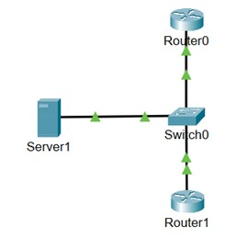

Step 1: Setup a simple network
- Open the Packet Tracker app.
- On the bottom left of packet tracer select the second icon (end devices).
- Choose the server icon. Drag to the main Packet Tracer Screen.
- On the bottom left of Packet tracer, first icon Network Devices, select Switches underneath Network devices.
- Select 2960 switch. Drag to the blank area inside packet tracer. Place it on the right side of the server.
- Select the Router icon. Choose one 2911 router and drag them to the blank area. Packet tracer should be above the switch on the right side.
- Select 2nd Router 2911 and drag to blank area of packet tracer. It should be below the switch on the right side (placements refer to physical diagram on page above).

Step 2: Connect the devices
- Select the lighting icon (fourth icon on the bottom-left) select copper straight-through cable icon (black solid line) select it. Drag it to server select fastethernet0 and connect to fastethernet0/1 on the switch.
- Wait until a green blinking light appears between the server and the switch.
- Connect the Routers to the Switch.
- Select on copper straight-through cable icon (black solid line) connect it to the switch port FastEthernet 0/2 and drag it to Gigabit Ethernet0/0 on Router 0.
- Select on copper straight-through cable icon (black solid line) connect it to the switch port FastEthernet 0/3 and drag it to Gigabit Ethernet0/0 on Router 1.

Step 3: Change hostname and configure IPv4 address on Router 0
- Select Router 0.
- Select the CLI tab.
- Type no and then press enter when you see the following message (Would you like to enter the initial configuration dialog [yes/no]:
- Press Enter to get the Router prompt and type the following commands and press enter after entering each command.
Router>enable
Router#config terminal
Router(config)#hostname Router0
Router0(config)#interface gigabitEthernet 0/0
Router0(config-if)#ip address 11.0.0.1 255.0.0.0
Router0(config-if)#no shutdown
Router0(config-if)#exit

Step 4: Configure SNMP on Router0
- Router0(config)#snmp-server community public ro
(Should say SNMP Agent on host Router 0 is undergoing warm start.)
- Router0(config)#snmp-server community private rw
- Router0(config)#exit
- Router0#write

Step 5: Change hostname and configure IPv4 address on Router 1
- Select Router 1.
- Select CLI tab.
- Type no and then press enter when you see the following message (Would you like to enter the initial configuration dialog [yes/no]:
- Press Enter to get the Router prompt and type the following commands.
Router>enable
Router#config t
Router(config)#hostname Router1
Router1(config)#interface gigabitEthernet 0/0
Router1(config-if)#ip address 11.0.0.2 255.0.0.0
Router1 (config-if)#no shutdown
Router1(config-if)#exit

Step 6: Configure SNMP on Router1
- Router1(config)#snmp-server community public ro
(Should say SNMP Agent on host Router 1 is undergoing warm start.)
- Router1(config)#snmp-server community private rw
- Router1(config)#exit
- Router1#write

Step 7: Configure the server
- Select the Server and go to the Config tab.
- Change the display name to: Server1.
- Select Desktop tab>select IP Configuration square icon.
- Select static radio button and enter the following IP configuration:
IP Address: 11.0.0.3
Subnet Mask: 255.0.0.0.
- Press x to close the IP configuration window.
- Select Desktop tab. Then select Command Prompt.
- Verify connectivity by using the following commands:
ping 11.0.0.1
ping 11.0.0.2
- The ping should return Reply back showing connection is ok. Close the Command Prompt and Server1 windows by pressing the x button.

Step 8: View Router0 SNMP messages on the server
- Select Server1 to open the console.
- Select Desktop > MIB browser (icon with word MIB on it).
- Select the Advanced tab and enter the following:
Address: 11.0.0.1
port: 161
Read Community: public
Write Community: private
SNMP version: Select down arrow and select v3
Note: SNMP version 3 is more secure in relation to authentication and encryption.
- Select OK.
- On the left pane of the MIB Browser, expand the following in order listed:
MIB Tree.
Router_std MIBs.
.iso.
Org
Dod
Internet.
Mgmt.
Mib-2.
- Select System.
- On the Operations dropdown box, select Get Bulk. Choose Go.
- Complete the following table using the info from the output:

Name/OID | Value | Type
 | What IOS software?
Version?
 | OID value?

Step 9: View Router1 SNMP messages on the Server
You’re now going to view system info from Router1.
- Select the Advanced tab and enter the following:
Address: 11.0.0.2
port: 161
Read Community: public
Write Community: private
SNMP version: Select down arrow and select v3
- On the Operations dropdown box, select Get Bulk. Choose Go.
- On the left pane, expand system and Select SysDescr.
- On Operations, above the Result Table, Select the dropdown box, select Get and then Go.
- Note your findings from the SysDesc result: Enter value.
- On the left pane, Select SysUptime.
- On Operations, above the Result Table, Select the dropdown box, select Get and then Go.
- Note down SysUpTime value: Enter value.
- On the left pane, Select SysName.
- On Operations, above the Result Table, Select the dropdown box, select Get and then Go.
- Note DownSysName: Enter value.
- Once this section is complete you can close the MIB browser window.

Activity 11: System upgrading and testing

Scenario
You are part of the IT team for a mid-sized business that has grown rapidly in the past two years. The current IT infrastructure is under pressure and struggling to meet operational demands.
The following key challenges have been identified:
- Storage bottlenecks: File servers often run out of space, causing downtime and poor performance.
- Lack of physical server room security: The server room is accessible to unauthorised personnel and lacks environmental controls.
- Manual update deployment: Patches and updates are deployed manually, causing inconsistency and delayed response to vulnerabilities.
Your team has been asked to propose and implement a system upgrade strategy. You’ll need to address each issue by making decisions on available upgrade options, testing activities, and change management considerations.

Objectives
For each challenge below, review the available upgrade options, select your preferred solution, and justify your choice. Then, decide on the testing you would perform before and after implementation.

Part 1: Storage bottlenecks
Upgrade options (choose one):
- Upgrade to a modern NAS with RAID 6.
- Implement a SAN with SSD-based storage.
- Expand existing DAS with larger HDDs.
Testing focus:
- Migrate during off-hours with full backups.
- Use a phased migration by department.
- Migrate all at once with minimal testing.

Decision justification
Answer the following questions now that you’ve made your recommendations:
- Which upgrade option would you suggest and why?

- How will your decision impact bottleneck issues in the future and does it provide scope for scalability?

- What are the potential challenges of your choice, and how can they be addressed?

Part 2: Server room security
Upgrade options (choose one or more):
- Install biometric access and CCTV.
- Use keycard access with logging.
- Lock the room and restrict access to IT staff only.
Testing focus:
- Install temperature and humidity sensors with alerts.
- Rely on manual checks.
- Use a basic fan and thermometer setup.

Decision justification
Answer the following questions now that you’ve made your recommendations:
- Which security upgrade option would you suggest and why?

- What are the potential challenges of your choice, and how can they be addressed?

Part 3: Manual update deployment
Upgrade options (choose one):
- Implement Windows Server Update Services (WSUS) or Linux package automation.
- Use third-party patch management software.
- Continue manual updates with a checklist.
Testing focus:
- Use a virtual test environment.
- Test on a few non-critical machines.
- Deploy directly to all systems.

Decision justification
Answer the following questions now that you’ve made your recommendations:
- Which update solution would you suggest and why?

- How will your decision improve deployment efficiencies?

Reflection
- How will success be measured post-upgrade (for example, uptime, deployment speed, security audits)?

- Which of the upgrade decision do you believe will have a long-term impact on the business? Why?

- What potential resistance might come from staff or departments? How would you address it?

- If one part of the upgrade failed (for example, patch automation), what contingency would you have?

- How can you apply this knowledge in your organisation?

Activity 12: System performance improvement

Scenario
You are an IT advisor for a growing professional services firm that has recently experienced frequent slowdowns, intermittent network outages, and inconsistent system response times. Employee productivity and customer satisfaction have begun to decline.
An internal review has identified the following challenges:
- Aging infrastructure: Some network switches and servers are over five years old.
- Unscheduled downtime: Unexpected system outages due to hardware/software failure.
- No formal maintenance plan: Issues are fixed reactively as they occur (‘firefighting mode’).
Your team has been asked to recommend system performance improvements and select an appropriate IT maintenance strategy to sustain long-term reliability and efficiency.

Objectives
Analyse the issues and make decisions for each phase below. For each, choose a maintenance strategy and justify your choice.

Part 1: Addressing aging infrastructure
Objective: Reduce system lag and risk of hardware failure.
Choose a maintenance approach:
- Corrective maintenance: Replace/repair components only after they fail.
- Preventive maintenance: Schedule regular hardware checks and upgrades based on manufacturer guidelines.
- Predictive maintenance: Use monitoring tools to replace hardware based on usage patterns or failure predictions.

Decision justification
Which strategy will you choose and why?

Part 2: Improving network performance
Objective: Minimise downtime and latency.
Choose a maintenance approach
- Reactive support: Fix issues as they occur, logging incidents for analysis.
- Proactive monitoring: Implement network monitoring tools with alert thresholds.
- Capacity planning and simulation: Regularly simulate peak loads and plan for network upgrades before congestion occurs.

Decision justification
What is your strategy, and how will you measure its effectiveness?

Part 3: Software/system maintenance
Objective: Ensure application performance and security without disrupting business operations.
Choose a maintenance approach
- Scheduled preventive updates: Regular monthly patches and software maintenance windows.
- Predictive and AI-based updates: Use intelligent update systems that adapt to usage patterns.
- Run-to-failure: Only update or patch when critical vulnerabilities or bugs emerge.

Decision justification
- Which approach do you recommend?

- How do you ensure minimal disruption while improving performance?

Reflection
- Which maintenance strategy did you find most effective for long-term performance and why?

- How would you justify the cost of preventive or predictive maintenance to management?

- How would your maintenance strategy address risk and user satisfaction?

- What metrics would you track post-implementation to evaluate success?

Activity 13: System performance monitoring

The intention of this lab activity document is to introduce you to this powerful, and often underutilised, tool. Once you have become more familiar with the interface, you will complete a practical lab to establish a system baseline during idle and then compare this to a performance trace when the system is under heavy load.
Objective: Install a performance baseline testing tool.
After completing this lab, you will be able to:
- Understand the need for performance monitoring.
- Differentiate between counters, objects, and instances.
- Create a system ‘baseline’ to help with troubleshooting.
Estimated total time: 20 minutes.

Instructions
- Install the BurnIn Test Pro trial version software on your Windows 10 client PC. Don’t run the application after the installation.
Note: Next you are going to create a performance baseline of your Windows PC. Open Performance Monitor and add suitable counters to measure the four key sub-systems on your machine: CPU, MEMORY, HARD DISK, and NETWORK.
- On Windows 10 client PC, select Start and enter perfmon to open the Performance Monitor console.
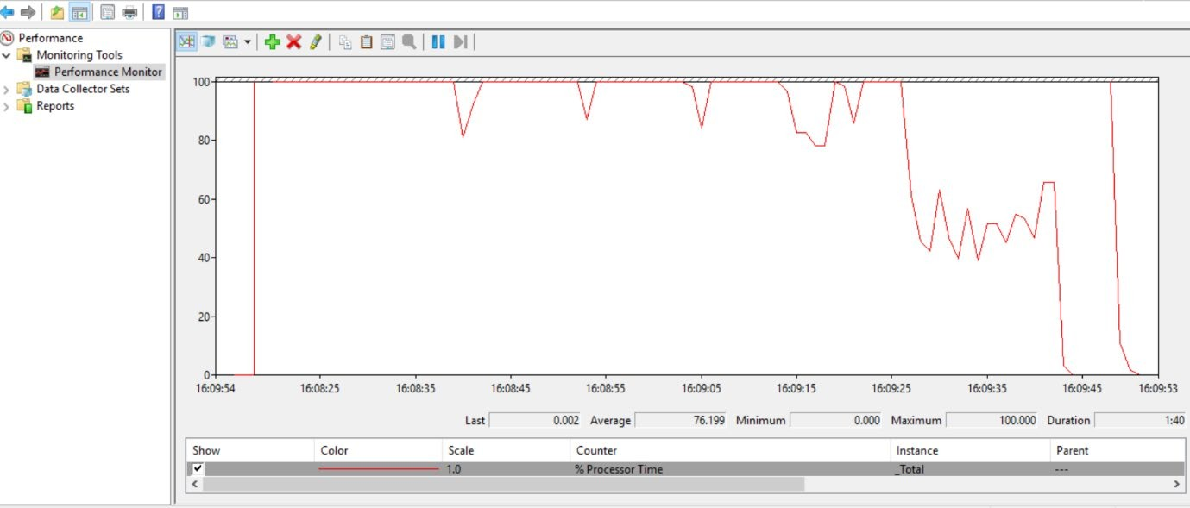

- Make sure the Performance Monitor is highlighted and then select the green plus icon to add some counters.
- Add Processor (CPU), Memory (RAM), and Network Adapter (Network) to the counters. Make sure to select and add the specific counters under each selection as shown below. Select processor, highlight the following, and select Add.
%C1 time
%C2 time
%C3 time
%Idle time
%Interrupt time
%Processor time
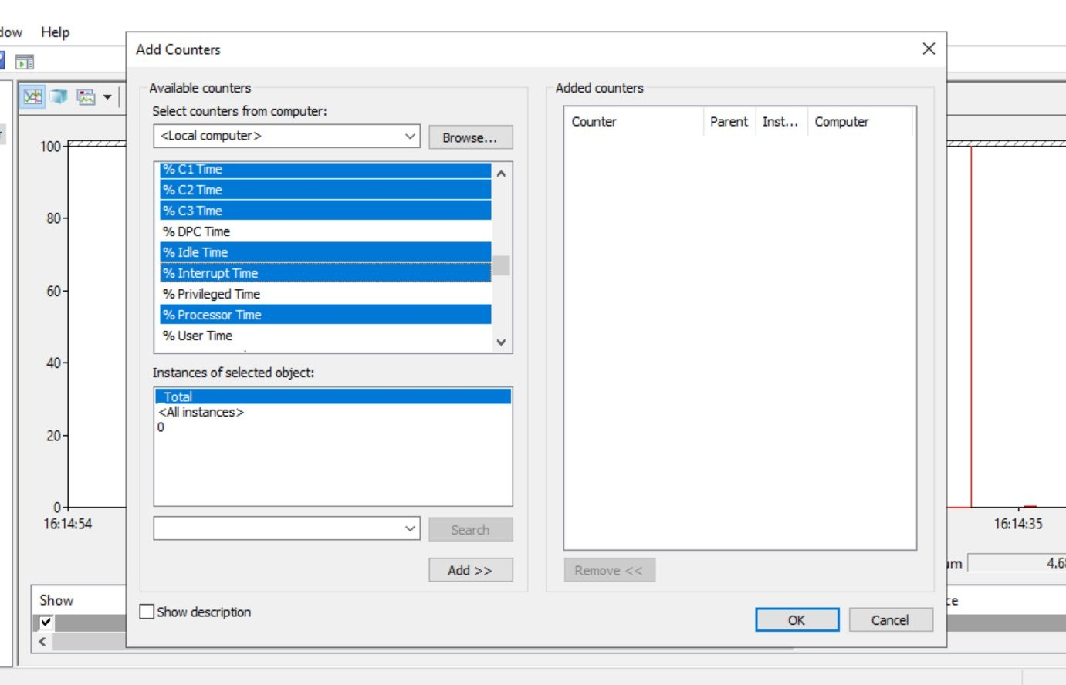
- Select Memory, highlight the following below, and choose Add:
% Committed Bytes In Use
Available Bytes
Available Kbytes
Available Mbytes
Cache Bytes
Cache Bytes Peak
Cache Faults/sec
Commit Limit
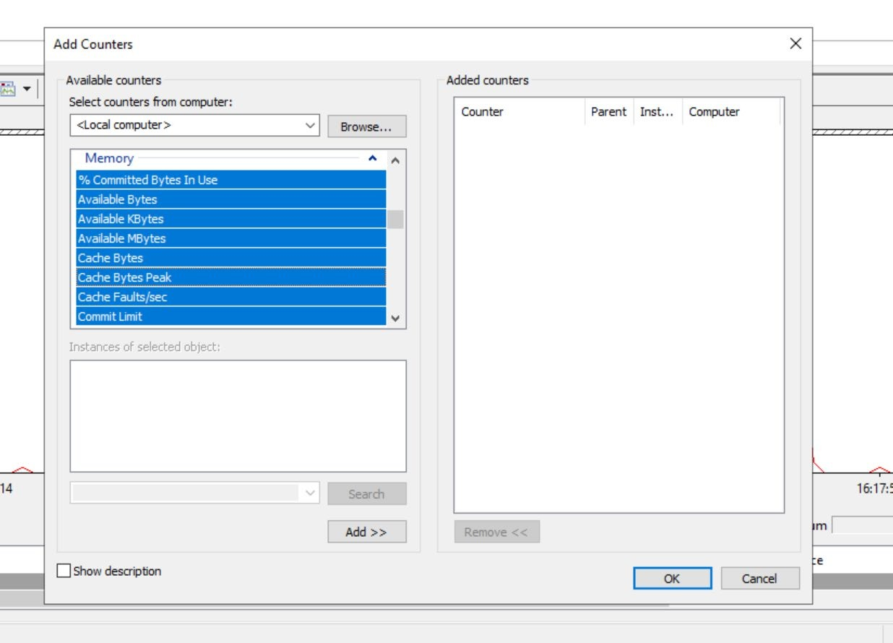

- Select Network Adapter, highlight the following adapter, and choose Add:
Intel[R] PRO_1000 MT Desktop Adapter
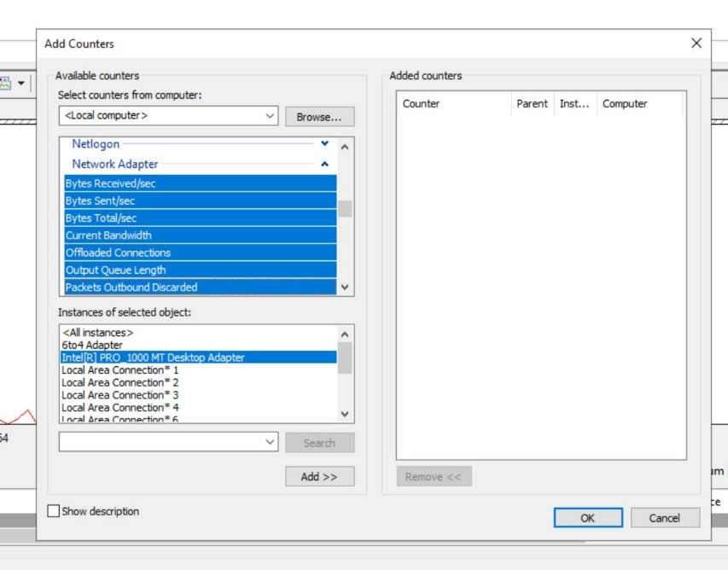
- Capture live data for 90 seconds whilst your machine is idling, then freeze the display and save the image as a .gif on your desktop, naming it ‘Before’.
- Next, double-click to run the BurnIn Test application and choose to continue with the 30-day trial.
- Select the option for Test Selection and Duty Cycles to choose which tests you would like to carry out, and at what load. Ensure the CPU, RAM, and Network tests are selected as a minimum and then select OK.
- Next select the green Play button to start your selected tests and allow the programme to begin stressing your system.
- With the BurnIn Test running, open Performance Monitor, select the green Play button to unfreeze the display, and then once again capture the live data for 90 seconds. When this is complete, freeze the display and save the image as a .gif on your desktop, naming it ‘After’.
- You can now Stop BurnIn stress tests and review the summary screen.
- Your final task is to now open both of the .gif images on your desktop and compare the various traces.

Reflection
- What did you learn about the structure and functionality of Windows Performance Monitor?

- Which system resources (CPU, memory, network) showed the most activity or stress?

- How would you use Performance Monitor in a real-world troubleshooting scenario?

- How can this tool help in proactive system maintenance?

- How would you compare Performance Monitor to other monitoring tools (Task Manager, Resource Monitor)?

Final note
This activity has only provided a simulated load on the client machine, but in a real-world scenario you would now be able to compare how the PC was performing at idle compared to how it performs under load. This is a highly valuable method of determining system bottlenecks and highlights hardware components that may be fatigued or due to fail.

Activity 14: Service Level Agreement

Scenario
You work for a Managed Service Provider (MSP) that delivers IT support, cloud hosting, and cybersecurity services to clients in various industries (healthcare, finance, retail). As the as the business expands, you're tasked with improving the way Service Level Agreements (SLAs) are created, implemented, and managed to better reflect client needs and service capabilities.
Currently, your organisation uses:
- Customer-based SLAs (specific to individual clients).
- Service-based SLAs (based on the type of service, for example, cloud backup, helpdesk).
- Multi-level SLAs (a combination of both, including organisation-wide and service-specific commitments).

Objectives
For each scenario below, choose the most appropriate SLA structure and make recommendations on response times, uptime, support scope, and penalty clauses.

Scenario 1: Healthcare client with mission-critical systems
Client requirements:
- 24/7 uptime for patient systems
- Compliance with data protection laws
- Rapid incident response
Choose the best SLA:
- Customer-based SLA
- Service-based SLA
- Multi-level SLA

Decision justification
- Which SLA type would you recommend for scenario 1. Why?

- What uptime should be specified as part of the SLA (for example, 99.99%)

- What response and resolution times should be included as part of the contract?

- What security and compliance guarantee clause must be included in the contract?

Scenario 2: Small retail client with basic support plan
Client requirements:
- Mon-Fri support, 9-5
- Support for POS systems and email
- Budget-conscious
Choose the best SLA:
- Customer-based SLA
- Service-based SLA
- Multi-level SLA

Decision justification
- Which SLA type would you recommend for scenario 2. Why?

- What uptime support hours would you include in the SLA?

- How would you define the priority level based on the scenario?

Scenario 3: Cloud backup service used by multiple clients
Client requirements:
- Used by clients across all industries
- Shared platform by different organisations
- Consistent backup frequency and recovery targets
Choose the best SLA structure:
- Customer-based SLA
- Service-based SLA
- Multi-level SLA

Decision justification
- Which SLA type would you recommend for scenario 3. Why?

- What availability uptime should be specified as part of the SLA (for example, 99.99%)

- Should there be any exclusion clause in the contract (errors from clients, applications)? Why?

Reflection
Be prepared to discuss your answers.
- Should you include penalty or bonus clauses?

- How often should the SLA be reviewed?

- Who is responsible for SLA monitoring and reporting?

- How does different SLA structures affect organisation ability to meet customer expectations?

- What challenges might arise when managing multiple SLA types across clients and services?

- How can SLAs help improve service transparency and trust?

- What should an organisation do if clients consistently breaches their responsibilities under the SLA?

Activity 15: Policy and procedure

Scenario
You are the Information Governance Officer at a mid-sized organisation that handles sensitive client data (for example, health records, client case files, or personal data). A recent internal audit revealed inconsistencies in how data is recorded, stored, and accessed by different teams.
Audit findings include:
- Incomplete or inaccurate client records.
- Staff saving files on personal drives instead of the secure server.
- No consistent version control.
- Lack of awareness around the data retention policy.

Objectives
Your task is to improve the accuracy and consistency of information management through effective policy and procedure implementation.
Review the scenarios below and make decisions about what policies or procedures should be introduced or enforced. Provide reasoning for your decisions.

Scenario 1: Incomplete data entries
Team members are entering partial information into the client management system due to time constraints and lack of clarity on required fields.
Question: What policy or procedure would you implement to ensure data completeness?
- Introduce mandatory data field validation rules in the system.
- Provide training and a checklist of required data.
- Implement a review and audit cycle for submitted records.

Decision and justification
Which option would you implement and why?

Scenario 2: Storing data on personal devices
Several staff have saved files to personal USBs or desktops to work remotely, risking data loss or breach.
Question: What policy or procedure would you enforce?
- Create a strict data storage policy prohibiting use of personal devices.
- Provide access to a secure remote working platform.
- Both A and B.

Decision and justification
Which option would you implement and why?

Scenario 3: Confusion over file versions
Team members are often unsure which document is the most current version, leading to duplicated or conflicting updates.
Question: How will you address this issue through policy?
- Implement version control procedures.
- Use a centralised document management system with audit trails.
- Provide staff training on document lifecycle management.

Decision and justification
Which option would you implement and why?

Scenario 4: Unclear retention and deletion practices
Some departments are retaining records indefinitely, while others delete them too soon, resulting in non-compliance risks.
Question: What policy or guidance would you introduce?
- Organisation-wide data retention policy with clear timelines
- Automated deletion based on document category
- Assign department leads to enforce retention compliance

Decision and justification
Which option would you implement and why?

Reflection
- Why is it important to have clear policies for data recording and storage?

- How can you ensure staff consistently follow information procedures?

- What role does training play in supporting policy compliance?

- If you noticed ongoing non-compliance, how would you respond?

Activity 16: Server backup
This lab activity involves installing and configuring different types of backups. You will create a folder on your desktop or C:\ drive and copy the folder ‘C:\Intel’ into that folder.

Objective
Install and configure backup on DC virtual machine.
After completing this lab, you will be able to:
- Install and configure Windows Server Backup.
Estimated total time: 20 minutes.

Step 1: Install and create incremental backup in Windows Server
- Boot the DC Virtual Machine and log in with the following credentials:
Administrator
Pa$$w0rd
- Select Start > Server Manager (if not already open).
- Wait for it to finish initialising.
- Select Add Roles and features and select next several times until you see the Select Features window:
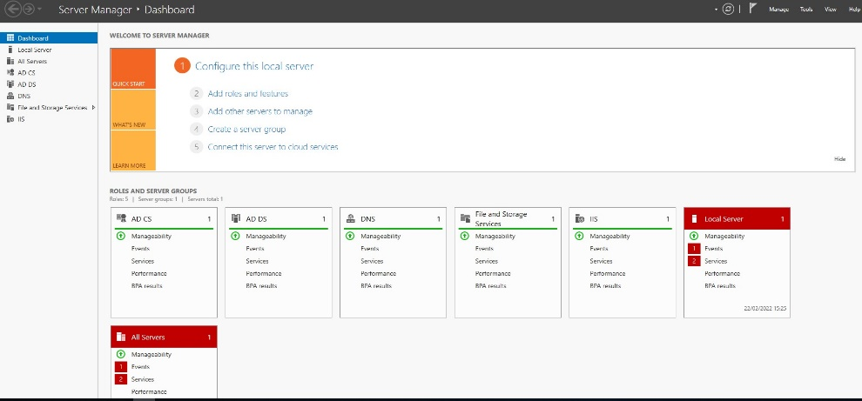
- Select Windows Server Backup and then Next.
- Check the box for the option Restart the destination server automatically if required and select Install (select Yes if you get a prompt).
- Select Install.
- Select Close when the installation is complete.

Step 2: Preparing a volume for backup

- Right-click the Start button and open Disk Management tool from the list.
- Select C: drive, then right-click and select Shrink Volume.
- Enter 5120 in the field labelled Amount of space to shrink in MB. Then select Shrink to confirm.
- This should create a new partition on Disk 0 with 5GB space in it.
- Right-click the new volume created and select New Simple Volume.
- Complete the wizard by selecting Next for every step to create a new Volume.
- It will ask you to format the new volume then select Format Disk to complete it.

Step 3: To create a scheduled incremental backup
- Select Start and open the Administrative Tools.
- Double-click Windows Server Backup to open the backup console.
- Select Local Backup.
- On the right side of the interface, you will find two backup types, Backup Schedule and Backup Once. Here you should select Backup Schedule.
- In the next screen, select Custom > Next (the full backup option will take too long to complete).
- In the Select Items for Backup window, choose Add Items, browse to the folder you created earlier on, and add it. Select Next.
- Select Once a day and specify any time of the day which is close to your current time to test the backup.
- Select Back up to a volume, then Next.
- Choose Add to select the partition that was created earlier on and select Next.
- Select Finish to create the backup schedule and then select Close.
Your system should have completed the backup on the time specified as shown in the image below.
Note: Create a folder called DailyBkp in the new partition and share the folder, giving everyone full permission. This is required for the next lab (Remotebackup).

Activity 17: Client remote backup
This lab activity involves creating a Windows 10 Backup to a Network Drive. Create a folder on your desktop or C:\ drive and add random files from ‘C:\Windows\System32\drivers\etc’ in the folder.

Objective
After completing this lab, you will be able to:
- Install and configure Windows Client Remote Backup.
Estimated total time: 20 minutes.

Step 1: Client backup
In this task, you will be installing and configuring the backup server role. Log on to the Windows 10 Hyper-V machine with the following credentials:
- Username: Administrator
- Password: password

- Open the Settings app.
- Select Update and Security.
- Select Backup, then select Go to Backup and Restore (Windows 7).
- Select Set up backup to set up a new backup.
- To select your network drive, choose Save on a network.
- On the Select a network location screen, add the network path in the field for Network location. For example: \\DC1\DailyBkp (this the folder you created in the Server partition).
- Under Network Credentials, enter administrator and Pa$$w0rd of a user account from the Server machine. Select OK when you’re done.
- Make sure the folder is selected from the list of available drives and select Next.
- Select Let me choose, then select Next.
- Select the folder you created in Windows 10 and deselect Include a system image of drives: System Reserve, (C). Select Next.
- Next to Schedule, select Change schedule and enter any preferred backup times and select OK (to test the backup, enter Daily and specify the nearest time to the current system time).
- Select Save settings and run backup to confirm your settings and begin the backup.
Note: Verify the folder was backed up to the network drive.

Activity 18: Disaster recovery planning (DRP)

Scenario
LB Solutions is a mid-sized managed service provider (MSP) with clients in healthcare, finance, and retail. They recently experienced a data centre fire that caused major outages for 36 hours. Although data was not lost, their recovery and communication processes were uncoordinated, and critical client services were delayed.

Objectives
The Manager has asked you, the Network Engineer, to design a more effective and resilient BCP and DRP strategy to reduce future downtime, ensure faster recovery, and improve stakeholder trust.

Scenario 1: Identifying DRP process steps
You’re building the new disaster recovery plan. What is the correct order of key DRP planning steps?
Choose the option with the correct order.
- Recovery strategy → Business impact analysis → DR team formation → Testing
- DR team formation → Business impact analysis → Recovery strategy → Testing
- Business impact analysis → Testing → DR team formation → Recovery strategy

Decision and justification
Which option would you implement and why?

Scenario 2: Choosing a recovery site
You need a backup site strategy for a healthcare client who requires minimal downtime and strict data compliance.
Which recovery site should you recommend?
- Cold site
- Warm site
- Hot site

Decision and justification
Which option would you implement and why?

Scenario 3: Integrating DRP with BCP
You’re advising leadership on aligning DRP and BCP. Which of the following ensures integration?
- Keep DRP focused on IT while BCP covers everything else.
- Build DRP as a subset within the broader BCP framework.
- Develop both separately, then combine into a crisis playbook.

Decision and justification
Which option would you implement and why?

Scenario 4: Testing and communication
You’re designing a test plan. What would be the most effective approach?
- Annual full recovery simulation
- Quarterly tabletop exercises and scenario walkthroughs
- No tests – rely on real events for learning

Decision and justification
Which option would you implement and why?

Reflection
- How can recovery site selection impact business continuity outcomes?

- What are the benefits of integrating DRP within BCP?

- Why is regular testing important even if no disasters occur?

- How can poor communication delay recovery in a disaster?

- What factors should influence the choice between cold, warm, and hot sites?

- What might happen if a business skips the Business Impact Analysis step in DRP planning?

Activity 19: Change management compliance

Project overview
- Change name:
- Date of implementation:
- Project lead:
- Change requestor:
- Business justification: (Briefly explain why this change is necessary.)

Risk assessment

Potential risks identified:
(List at least three risks associated with this change.)

Impact on business operations:
(Describe how these risks could affect the organisation.)

Mitigation strategies:
(How will you prevent or reduce these risks?)

Testing strategy

Testing environment used:
(For example, lab, virtual environment, staging server, sandbox network.)

Testing procedures conducted:
(Describe what was tested and how.)

Implementation plan

Planned change window:
(For example, weekend, off-peak hours, after-hours maintenance.)

Step-by-step deployment plan:
(List the exact steps to implement the change.)

Rollback plan (in case of failure)

Criteria for rollback:
(At what point will the team decide to revert changes?)

Rollback steps:
(List the exact steps to revert to the previous state.)

Post-implementation review and performance metrics

Success criteria:
(How will we measure whether the change was successful?)
- Increased network performance (Yes/No)
- Improved security measures (Yes/No)
- Reduced downtime (Yes/No)
- Other:

Final approval and sign-off
- Project lead signature:
- Date:
- Change approved by:
- Date:

Lab virtual machines credentials
These are the credentials to log on to the virtual machines to complete the session labs.

DC
- Username: Administrator
- Password: Pa$$w0rd

Windows 10
- Username: admin
- Password: password

Ubuntu
- Username: Student
- Password: Pa$$w0rd



